Stabilization Demo Document for SDET-Retail-App using Playwright
App: SDET-Retail-App
Author: Justin Philip
Date: 04/07/2026
Environment: Local System
Browser: Chrome

Test Report
Test Environment:
Application: SDET Retail-Application
Test Automation Framework: Playwright
Browser: Chromium
Environment Type: Local Development Environment

Test Objective
To evaluate application resilience and test stability under unstable network conditions, asynchronous processing delays, and timing-related race conditions.
Simulation Techniques Used
- Network request interception
- Artificial API delays
- Request failures
- Random response behavior
- Repeated test execution
Validation Strategy:
The same test is executed multiple times to identify intermittent failures and verify stabilization after implementing corrective measures.

Scenario 1 – Flaky Test Caused by Network Instability During Sales Synchronization
Test Objective:
Validate that a newly queued sale is successfully synchronized and reflected in the Local Outbox.
Failure Simulation Strategy:
To simulate real-world network instability, the sales API endpoint was intercepted and manipulated using Playwright routing.
The following behaviors were introduced:
- 25% Probability: API request aborted.
- 25% Probability: API response delayed.
- 50% Probability: API responds normally.
- await page.route("**/api/sales", async (route)=>{
- const random = Math.random();
- if(random<0.25){
- log.warn("Request is aborted, due to unexpected circumstances");
- route.abort('failed');
- console.log(random);
- }else if(random<0.50){
- const delay = 100 + Math.random() * 100;
- log.warn(`API is slow; Expected Delay ${delay} ms`)
- await new Promise(resolve => setTimeout(resolve, delay));
- await route.continue();
- }else{
- log.warn("Simulated correct API response");
- await route.continue();
- console.log(random);
- }
- })
This simulation reproduced intermittent network conditions that users may experience in production environments.

Test Scenario
Steps Performed
- Open POS page.
- Verify application is online.
- Reset local outbox.
- Confirm no queued sales exist.
- Queue a new sale.
- Verify synchronization completion.

Symptom
The test intermittently failed while validating the synchronization status of a newly queued sale.
Failure Message
Error: expect(locator).toHaveText(expected) failed
-------------------------------------------------------------------------
Locator: getByTestId('outbox-status')
Expected: "synced"
Error: element(s) not found
Observed Behavior
During failed executions:
- Sale was queued successfully.
- Synchronization request was either delayed or aborted.
- Synchronization status element never appeared.
- Assertion failed while waiting for the status.

Evidence
Figure 1 – Overall Test Execution Report: Playwright execution report showing intermittent failures during repeated execution.
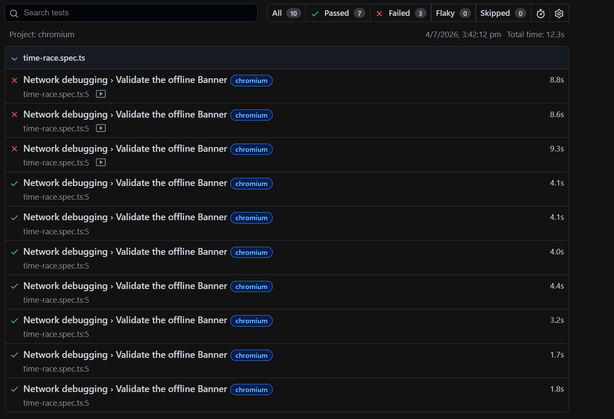
Figure 2 – Failed Assertion
Figure 2 – Application state captured during test failure. Synchronization status element was either not synchronized or not present when the assertion executed.
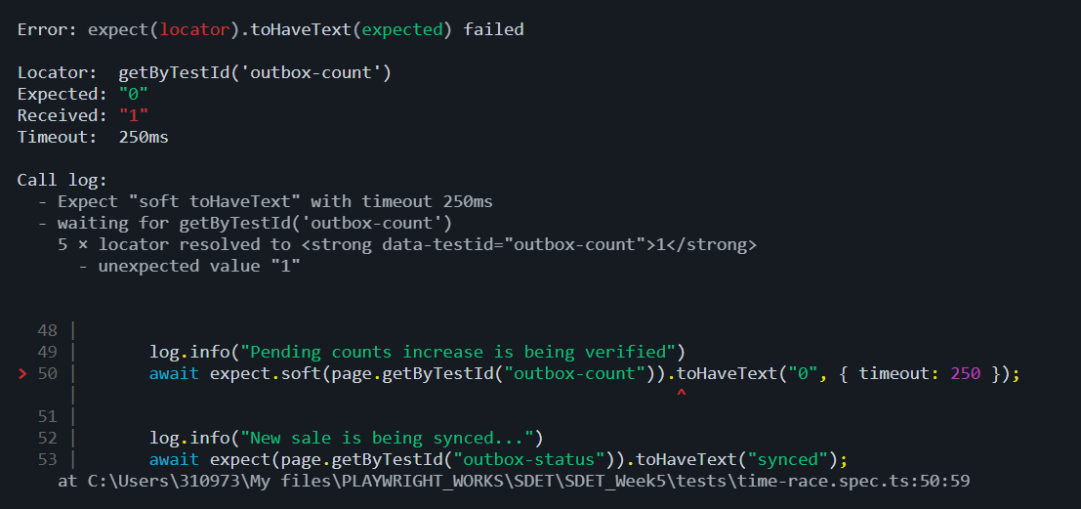
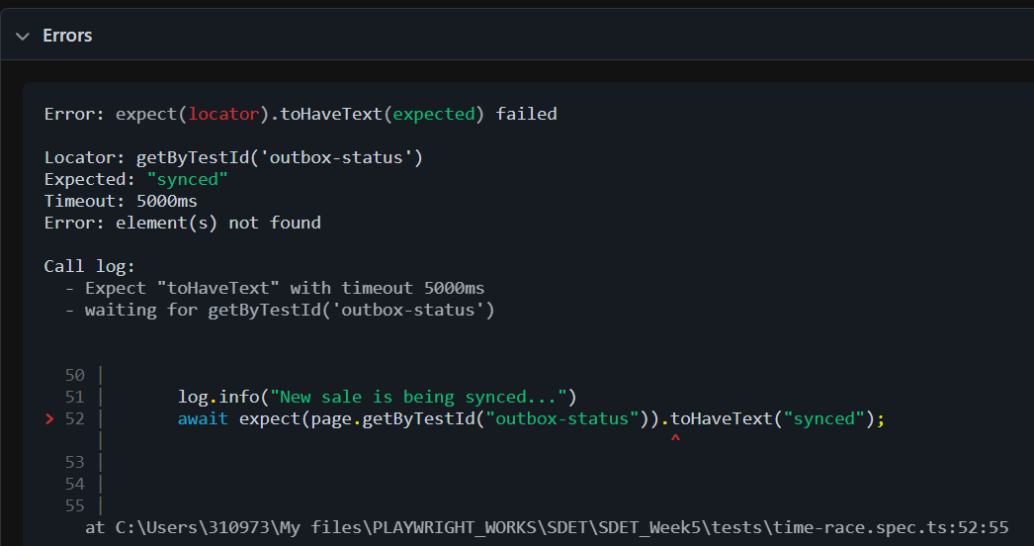
Figure 3 – Playwright Trace Timeline showing the sequence of actions leading to the synchronization failure.
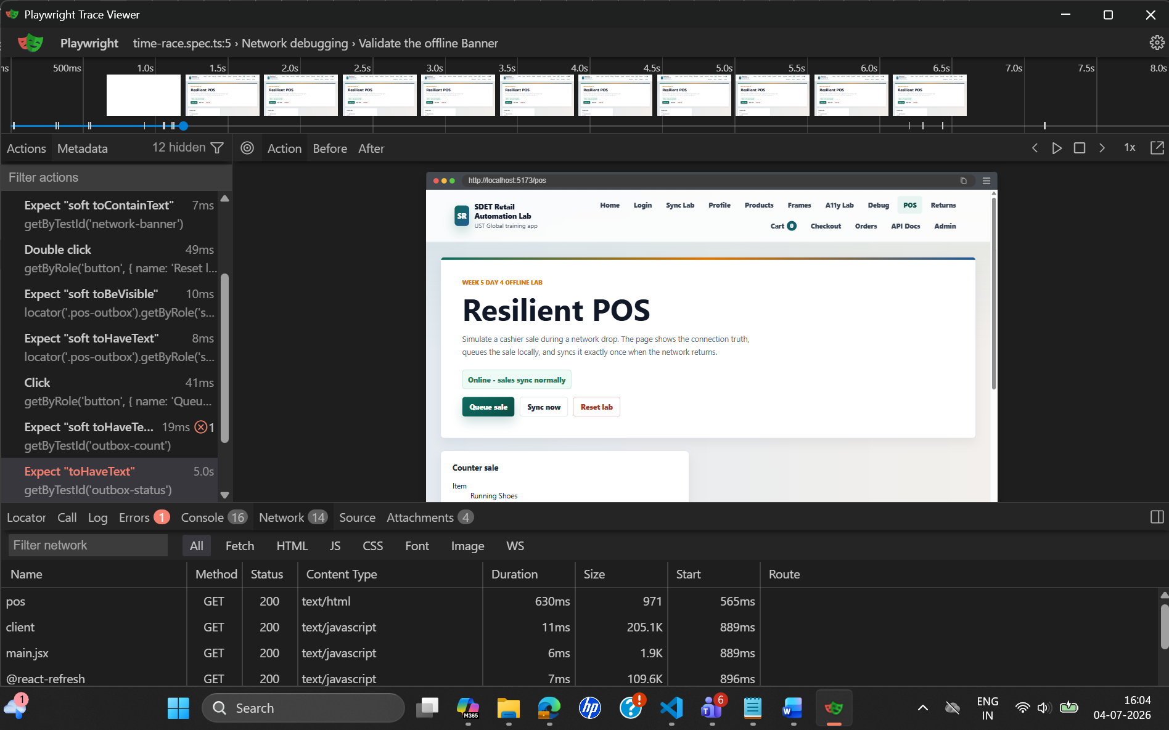

Root Cause Analysis
The synchronization process relies on a successful response from:
/api/sales
The test intentionally introduced unstable network behavior.
Execution Flow During Failure
Queue Sale
↓
POST /api/sales
↓
Network Delay / Request Abort
↓
Synchronization Incomplete
↓
outbox-status Element Not Created
↓
Test Assertion Executes
↓
Failure

Fix Implemented
The test was using an aggressive timeout and validating the final synchronization state before the synchronization workflow completed.
Before
log.info("Pending counts increase is being verified");
await expect.soft(page.getByTestId("outbox-count")).toHaveText("0", { timeout: 250 });
log.info("New sale is being synced...");
await expect(page.getByTestId("outbox-status")).toHaveText("synced", {timeout: 250});
After
log.info("Pending counts increase is being verified");
await expect.soft(page.getByTestId("outbox-count")).toHaveText("0", { timeout: 10000 });
log.info("New sale is being synced...");
await expect(page.getByTestId("outbox-status")).toHaveText("synced", {timeout: 10000});

Proof:
Running 50x for flakiness
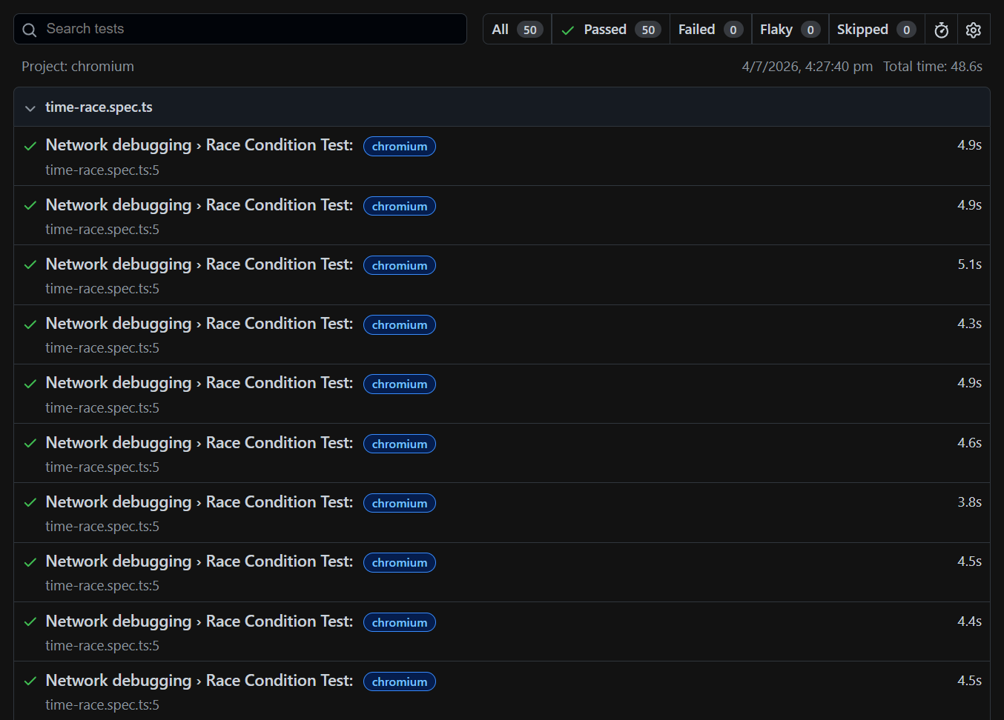

Scenario 2 – Currency Precision Defect Caused by Floating-Point Arithmetic
Test Objective
Validate that a partial refund is calculated and displayed accurately using currency values without losing precision.

Failure Simulation Strategy
To simulate a real-world financial calculation defect, the refund amount returned by the Refund API was intentionally modified before being rendered in the UI.
The original refund amount: -> 34965 paise = ₹349.6
was artificially reduced by 1 paisa: -> 34964 paise = ₹349.64
const amountRupees = amountPaise / 100;
const adjustedAmount = parseFloat((amountRupees - 0.01).toFixed(2));
amountPaise = Math.round(adjustedAmount * 100)

Test Scenario
Steps Performed
- Seed a paid order.
- Create a partial refund request.
- Verify refund calculation in the API response.
- Navigate to the Returns page.
- Validate displayed refund amount.
- Validate refund status.

Symptom
The test failed while validating the displayed refund total.
Failure Message
Error: expect(locator).toHaveText(expected) failed
Locator: getByTestId('refund-total')
Expected: "₹349.65"
Received: "₹349.64"
Timeout: 5000ms
Evidence
Figure 1 – Playwright Execution Report:Playwright execution report showing failure in refund amount validation.
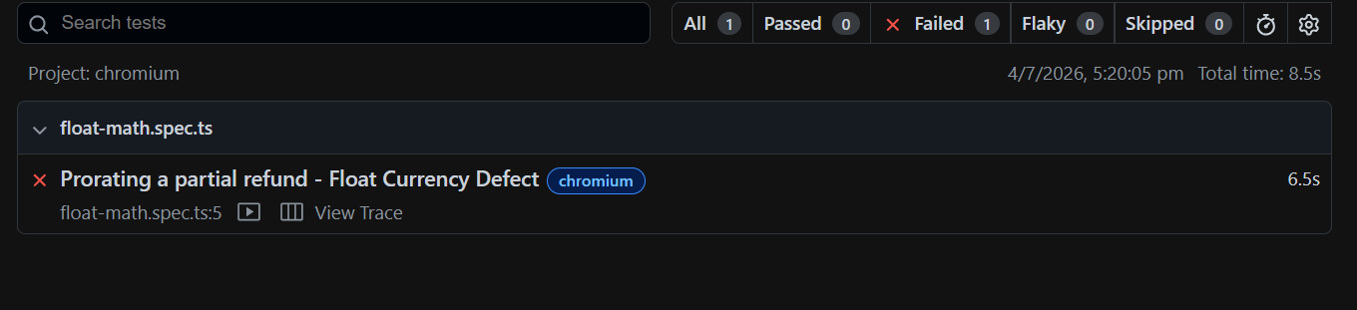

Figure 2 – Refund amount validation failure showing expected and actual values differing by one paisa.
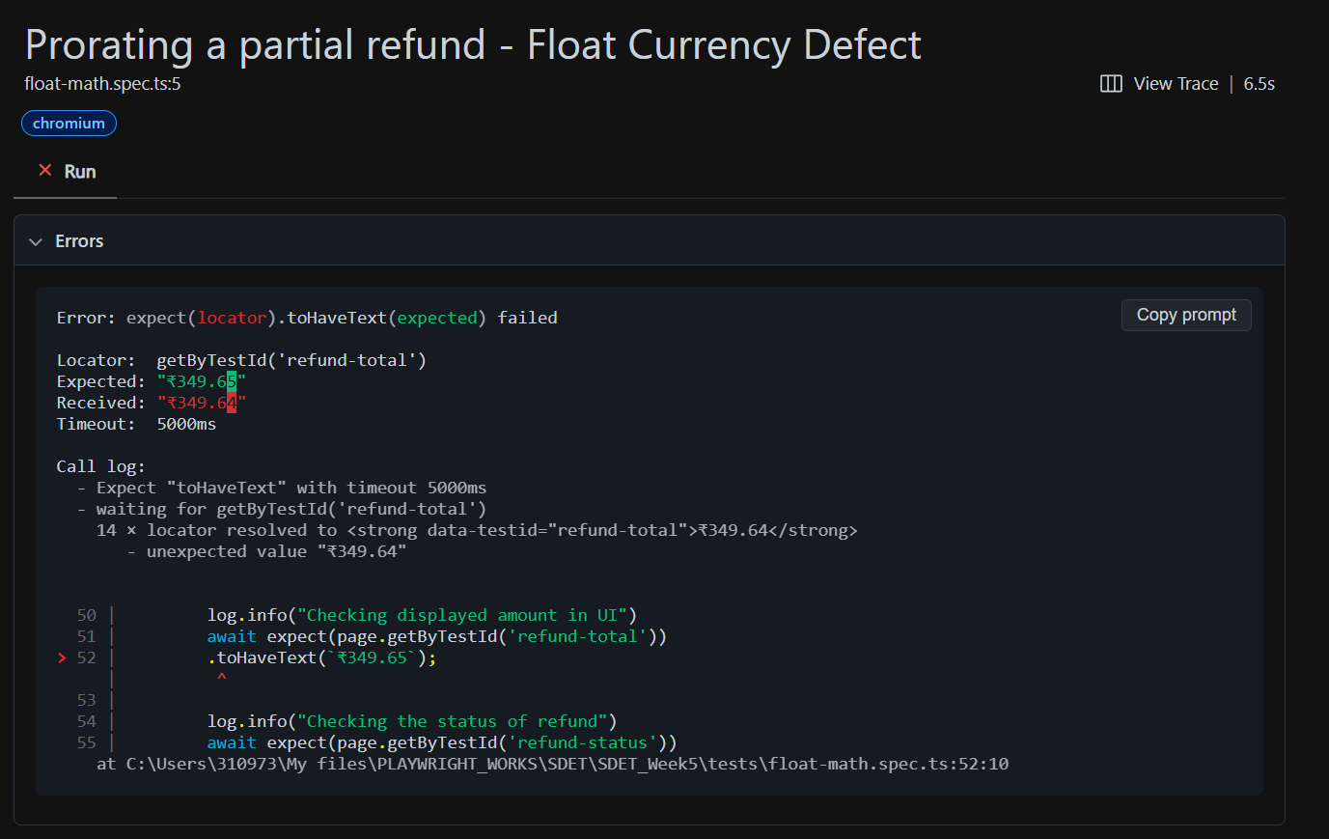

Root Cause Analysis
The refund calculation workflow depends on accurate handling of monetary values.
Expected workflow:
34965 paise
↓
349.65 rupees
↓
Float manipulation
↓
349.64 rupees
↓
Converted back to paise
↓
34964 paise
↓
Displayed to User
Fix Implemented
The defect originated from handling monetary values using floating-point rupee calculations:
Before:
const amountRupees = amountPaise / 100;
const adjustedAmount = parseFloat((amountRupees - 0.01).toFixed(2));
amountPaise = Math.round(adjustedAmount * 100)
After:
const refundAmountPaise = unitPaise * quantity;
const refundAmountRupees = refundAmountPaise / 100;

Proof:
